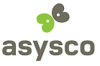

Migration
Technology
OS2200 COBOL to AMT LION

Asysco is:
- THE leader in Unisys mainframe migrations, with more than 20 years in the Unisys Marketplace!
- Dedicated to helping the Unisys Marketplace make a smooth transition from the mainframe environment to the Windows environment.
- Staffed with Unisys developers with more than 20 years worth of Unisys expertise.
- Able to understand and provide for all of the nuances in the Unisys OS/2200 environment.
- Dedicated to ensuring a smooth and painless migration path to the mainframe users, understanding their unique needs and wants.

What Gets Migrated?

Asysco’s focus is strictly on the Unisys marketplace. Every corner of a mainframe environment is discovered and dealt with:
- The applications,
- The jobs that are used to deal with batch processing,
- The actual data in the mainframe databases.

What Asysco converts for the OS/2200 environment include, but are not limited to:
  - COBOL (DMS, DPS),
  - MASM/Assembler,
  - Executive Control Language (ECLs),
  - SSG,
  - Flat files, and
  - Data based on the DMS Schema and Subschemas

The Asysco migration team recognizes each of the above have different migration requirements and therefore has created multiple translators to handle each separately.

All of this migration is done with absolutely NO changes to your organizations’ business logic. Your current business rules are preserved and no re-engineering is required.

Asysco provides an entire migration package, from discovery to go-live, that affords their clients quicker time to market, easier transition into the Windows environment, all at a fixed price!

What is AMT-LION?

The Asysco Migration Technology offers its users a quick and easy migration path to the Windows environment – AMT-LION.

- AMT-LION – The original, flagship proprietary product of Asysco, providing its clients a migration path to a Windows and SQL environment.

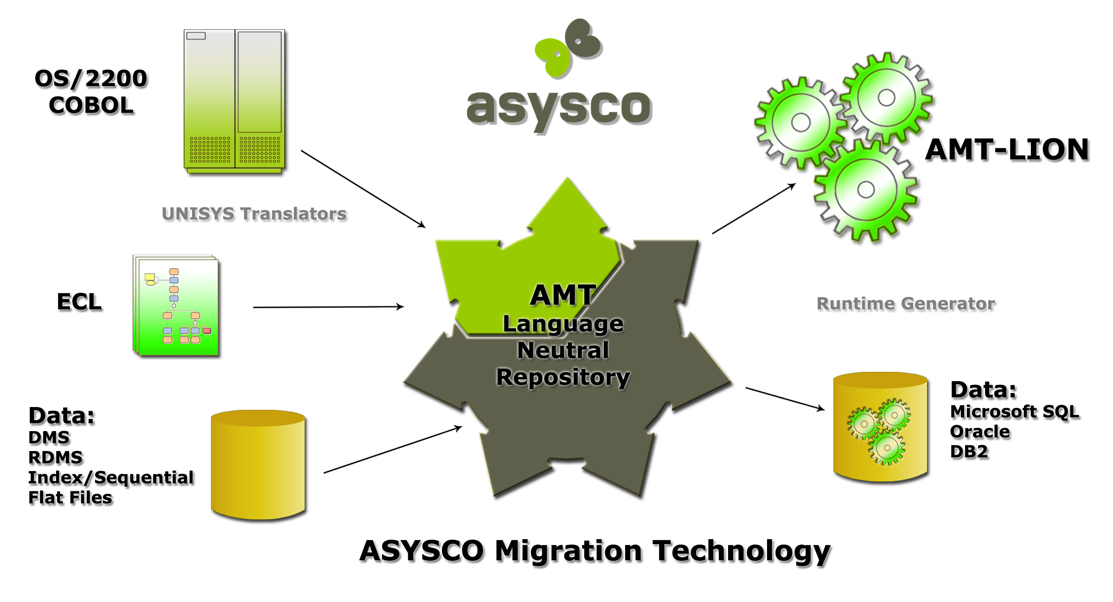

AMT-LION
- Provides clients with a migration path that is second to none.
- Migrates your business rules unchanged.
- Does not increase the number of lines of code your developers have to maintain.
- Provides its own language and development environment to maintain, enhance and create new applications.
- Eases the transition of the mainframe developers into the Windows environment because of the similarities between LION and COBOL.
- Converts the ECLs to VB Scripts.
- Reduces the amount of training needed for the developers to learn the new language because of these similarities.
- Handles the COBOL database commands such as Find/Fetch First, Fetch Next, Currency issues, Automatic/Manual members, etc.
- Allows for the use of Web Services.
- Migrates the COBOL applications as web-enabled, with no coding changes!
- Allows the legacy DMS/RDMS database description (Schema and Subschemas) and the data to be migrated to the SQL, relational database of the client’s choice: MS SQL, Oracle or DB2.
- Provides control center operations functions that mainframe users have become so used to such as:
  - Server Maintenance,
  - Job Control,
  - Security,
  - Message Center,
  - Performance Statistics, etc.
- Ability to control reports with the Report Management function,
- Allows queries against the new SQL database with the Real Time Query function
- Ability to view past transaction paths logged by users with the Transaction Playback function.
- Significantly reduces the amount of testing an organization needs to complete due to fact that the business logic does not change.
- Drastically reduces the amount of training needed for end users because during the migration the processes and the screens needed to do their job do not change.

